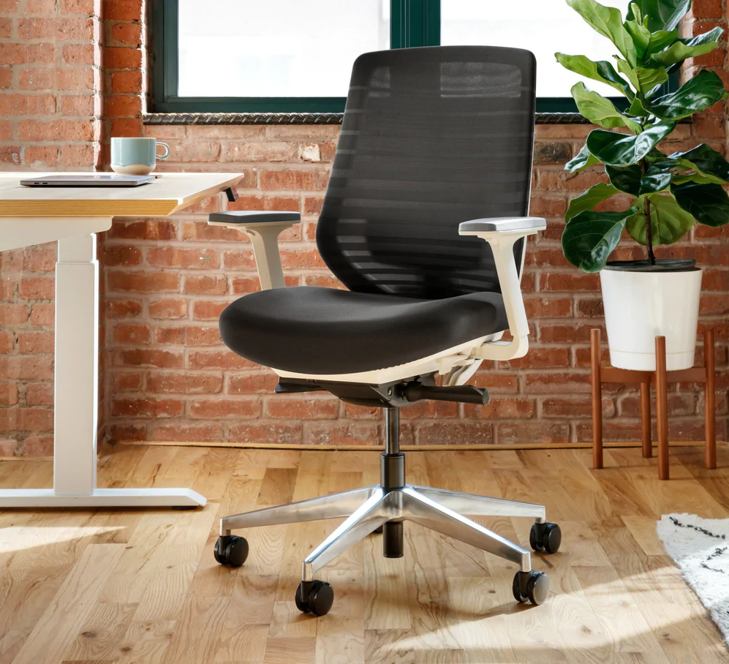

Branch office Chair

Designed in Italy and featuring eight points of adjustment, the Branch Ergonomic Chair delivers an exceptional range of ergonomic support for bodies of all shapes and sizes.

* Eight points of adjustment for a complete fit: 3D armrests, height, tilt and tilt tension, seat depth and removable lumbar rest
* Double layered mesh backrest for durable, breathable support
* High-density cushion supports 275 pounds and 8+ hours of work
* Synchronous mechanism links backrest and seat pan to tilt in unison
* Five star anodized aluminum base
* Meets the BIFMA standard for commercial-grade use
* Expert and user approved: awarded Best Office Chair by Gear Patrol, TechRadar, Tom's Guide, CNN, WIRED and 1000's of five star reviews

